The Man Who Changed Humor in America Forever

Before it was a magazine, *MAD*was a satirical comic that ran under the inimitable leadership of Harvey Kurtzman.

By [Steven Heller](https://www.theatlantic.com/author/steven-heller/)

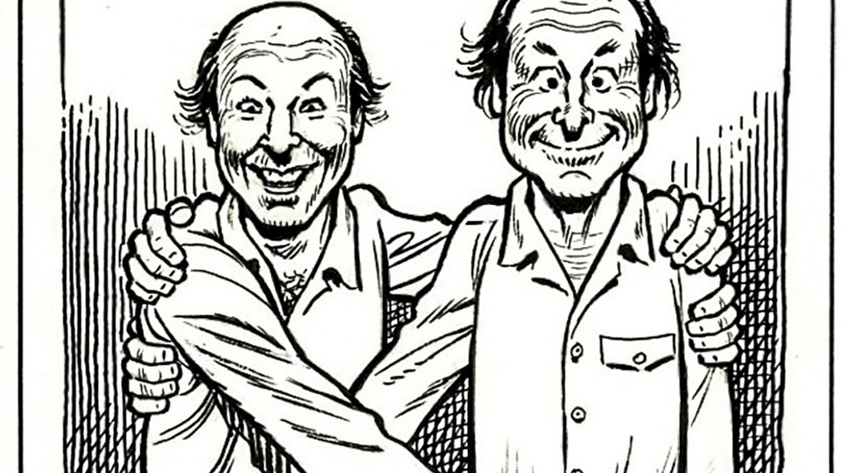

Harvey Kurtzman and Will Elder, collaborators in MAD and Playboy, as drawn by Elder. Courtesy the estate of Will Elder.

APRIL 30, 2015

SHARE

The famous publishing mascot Alfred E. Neuman—a big-eared, freckled boy with a wide grin missing a tooth—represents our country’s mid-century modern humor and the genius that made it happen: Harvey Kurtzman, founder of the original *MAD* comic book in 1952. It ran for 23 issues as an extraordinary satirical comic under the EC (Entertainment Comics) imprimatur, before becoming a magazine in 1955, but from its earliest days, *MAD*has been the quintessential deflator of folly and conveyor of “humor in a jugular vein.”

Kurtzman, who died at 68 in 1993, was the Matt Groening/Jon Stewart/Tina Fey of his day. The title of a new, exhaustive biography by Bill Schelly out May 2, *Harvey Kurtzman: The Man Who Created MAD and Revolutionized Humor in America*, makes this exceptionally clear, giving Kurtzman a hero’s welcome into the pantheon of American cultural pioneers.

Τέλος φόρμας

“In *MAD*, Kurtzman challenged the repressive status quo in the early 1950s by satirizing cultural figures, politicians, and rampant consumerism,” Schelly told me in an email. “That kind of self-referential satire became the primary mode of humor in American culture, from *Saturday Night Live* to *The Simpsons*. I believe the questioning of authority in *MAD*led in some way to the counterculture moment of the 1960s and the anti-Vietnam war protests.”

Schelly became a Kurtzman fan before he knew his name, via the frequent *MAD* paperbacks of the 1960s that reprinted many of his best comics. “His name was omitted," he says, "but that didn’t stop me from laughing myself sick over stories like ‘Superduperman’ and ‘Woman Wonder!’” Kurtzman took aim at popular culture with parodies of brand-name heroes like these, which, while full of in-jokes, appealed to every boy of a certain age. An avid comic-book reader in his youth, Schelly discovered Kurtzman’s serious war stories in EC comics’ *Two-Fisted Tales* and *Frontline Combat*, which were published in the early 1950s at the same time as *MAD*. “Their ‘war is hell’ theme really hit home to me, a 19-year-old eligible for the draft in 1970," he says." By then, I knew Harvey Kurtzman’s name, and always wanted to know more about what made him tick, and how he created those brilliant comics. That’s why I wanted to write this biography.”

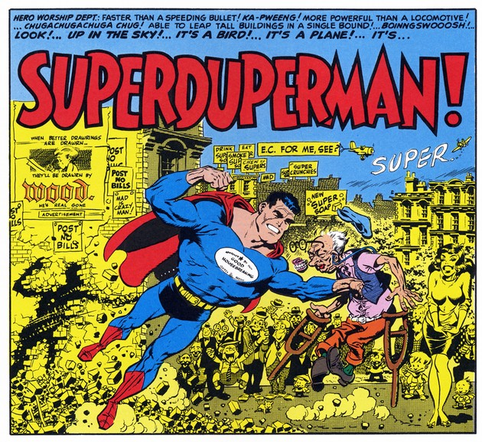 Copyright William M. Gaines Agent, Inc.

*MAD* made a lasting impact on comics artists like R. Crumb and Art Spiegelman. As soon as Kurtzman left the magazine in 1956, the satire in *MAD*lost much of its nuanced relevance. “Others used what he did as a template, but an imitation can never match up to the original.” Schelly said. “He never would have run features like 'Spy vs. Spy' and 'The Lighter Side of …' for decades. The magazine under Kurtzman wouldn’t have been a predictable quantity, which probably means it wouldn’t have sold as well.”

*Harvey Kurtzman: The Man Who Created MAD and Revolutionized Humor in America*is exhaustively researched: The book is 642 pages, and the footnotes alone take up 27 of them. But in addition to the detail about why Kurtzman invented *MAD* are chapters about his childhood, and the early friends who became part of his lifelong comics circle. Although many went to the newly opened Music and Art High School in New York, the book raises the question of why they so ardently embraced satire.

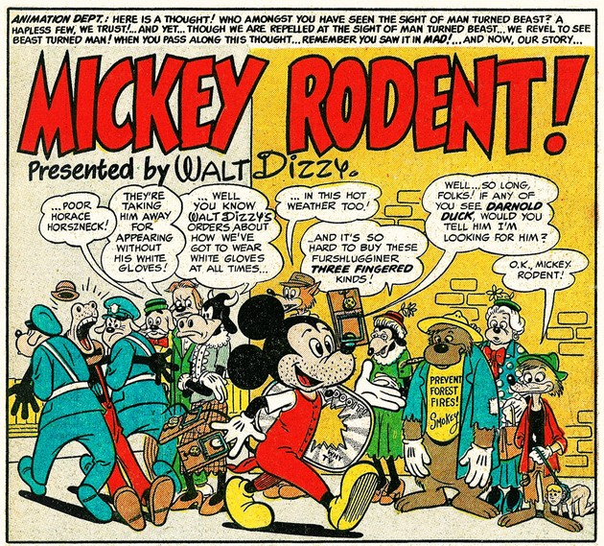“Mickey Rodent!” by Kurtzman and Elder from *Mad* #19 (1955). Copyright William M. Gaines Agent, Inc.

“Since they grew up during the Great Depression, I think satire was their way of criticizing the excesses and pitfalls of capitalism,” Schelly says. “Probably the central theme of *MAD*is skewering hypocrisy, and the early 50s was a time of incredible hypocrisy. Society was obsessed with outward appearances and apparent morality, while under the surface, things like racism, injustice, fear of the atomic bomb, and political paranoia were seething.” But Kurtzman didn't consciously plan *MAD* as a way of making a critical statement. "It just happened that way, because he was working quickly and instinctively, and unconsciously headed in that direction."

*MAD*’s revolutionary spirit ran counter to the repressive Comic Book Code Authority, a self-policing industry group of publishers formed in 1955 that promised to rid comics of the sex and violence. That same year, *MAD* became a magazine, and a year later Kurtzman took his leave. It takes Schelly two chapters in the book to lay out all the reasons why, but the one Kurtzman most often cited was that publisher Bill Gaines refused to spend money to maintain the quality of *MAD* in its new format. Freelance writers earned $25 a page, “which he called a ‘schlock rate.’”

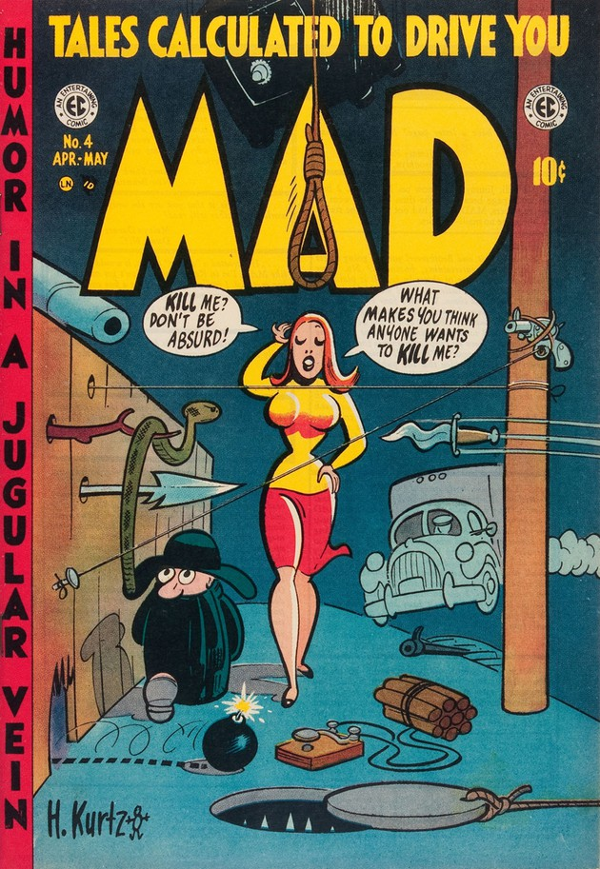Copyright William M. Gaines Agent, Inc.

After Kurtzman left in 1956, he tried his hand at three other humor magazines, *Humbug, Help,* and *Trump*, often with some of the same people from *MAD*, but in varying formats and frequently with lower budgets. “Unfortunately, lightning didn’t strike twice,” Schelly said. *Humbug* was an attempt to do a more adult satire magazine, but while slightly more sophisticated, it never quite eclipsed the original greatness of *MAD*.

During the four years working on this book, Schelly stumbled upon various revelations, including government documents detailing an FBI investigation of Kurtzman’s war comics by J. Edgar Hoover. “I was surprised to discover some of his personal contradictions," he says. "He was a writer-artist with both a towering confidence and a deep insecurity about his work. He was, in my estimation, a creative genius, and could have been an egomaniac, but he was genuinely modest about his work and his influence on other cartoonists." As a biographer, Schelly hopes to make up for Kurtzman's humility somewhat, by showing readers that, as the first producer of serious comic books, *MAD*'s creator proved “that the sequential art form could be Art with a capital 'A'."

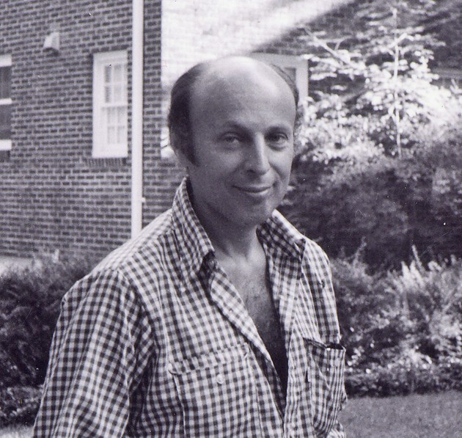Copyright William M. Gaines Agent, Inc.