**GRAPHIC CONTENT**

The Graphic Novel Versions of Literary Classics Used to Seem Lowbrow. No More.

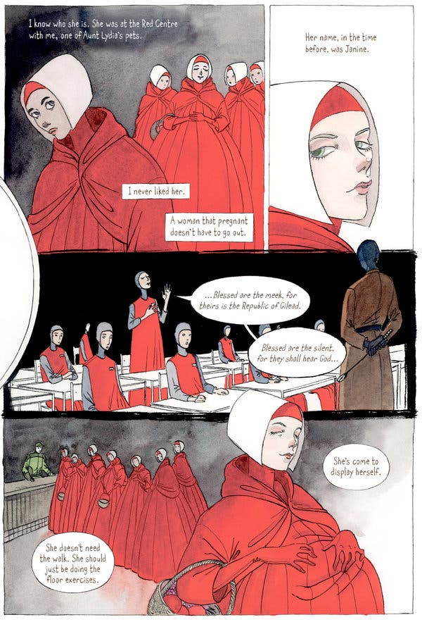



For fans of “The Handmaid’s Tale,” Renee Nault’s drawings offer another perspective on life in Gilead.Credit...From "The Handmaid's Tale"

**By Hillary Chute**

* Nov. 12, 2019

The form of comics is often associated with the practice of adaptation — from the big-budget, inescapable, explosion-filled, enormous-scale superhero films that have dominated the box office in the last decade to the enduring tradition of Classics Illustrated, which gave the world the comics version of “Moby-Dick.” A publishing venture that began in 1941 to offer shorter, comics-form adaptations of famous literary works, Classics Illustrated helped cement the belief that comics were easier renderings of a harder, worthier thing.

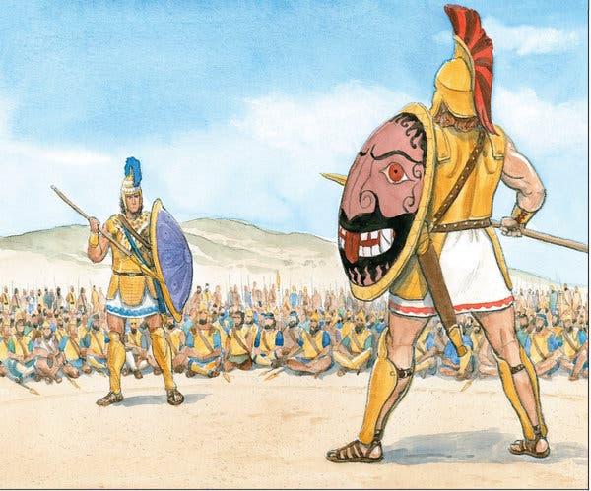

Image

“The Iliad” once again proves its timelessness in Gareth Hinds’s graphic adaptation.Credit...From "The Iliad"

Wherever you turn these days, there seems to be a comics iteration of this or that important book, from the official 9/11 Report to 2018’s “To Kill a Mockingbird,” authorized by the notoriously difficult estate of Harper Lee. Given the prodigious amount of visual culture already generated by Margaret Atwood’s ubiquitous “The Handmaid’s Tale,” it’s no surprise to find **THE HANDMAID’S TALE: The Graphic Novel**(Nan A. Talese/Doubleday, $22.95), adapted and illustrated by the Canadian artist Renee Nault. (Atwood, who just won her second Booker Prize, has published her own comics: In 2016 she was the co-creator, with the artist Johnnie Christmas, of the graphic novel series “Angel Catbird.”) Nault manages something difficult, which is to make the visual world of Atwood’s dystopian Gilead her own, interpreting the uniforms and even the iconic head gear of the handmaids differently from the popular television show; she even defies Atwood’s description and presents the protagonist Offred as dark-haired. The graphic novel gives another vision of Atwood’s dystopia, but Nault’s spindly-skinny characters look distractingly like fashion illustrations; even the supposedly drab outfit of the “Econowives” appears glamorous in Nault’s dreamy rendering. The effect is altogether too pretty.

If the Classics Illustrated idiom has suggested that comics versions of literary works are a kind of cheat sheet — and hence less valuable — a new crop of adaptations reveals the efficacy and the complexity of graphic takes on celebrated stories. Most conspicuous among these is Gareth Hinds’s **THE ILIAD: A Graphic Novel Adaptation**(Candlewick, $27.99), a careful, informative and compelling rendering of the Greek epic poem of the legend of the Trojan War — specifically the reverberations of the dispute between the warrior Achilles and King Agamemnon. Hinds’s drawings are vibrant and muscular. The acknowledgments reveal he spent eight months coloring the book, which features immortals as luminous beings who take shape in outline with identifying hues. They routinely interact with more opaquely colored humans; touchingly, we see ethereal goddesses sadly cradling their more embodied-looking adult sons.

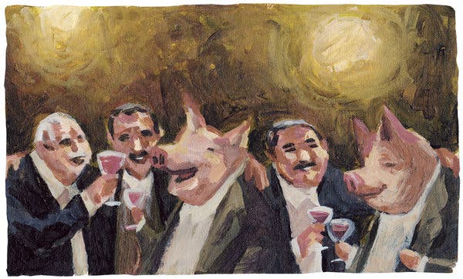

Image



Man or pig? Pig or man? As George Orwell wrote in “Animal Farm,” “Already it was impossible to say which was which.”Credit...From "Animal Farm"

Hinds’s approach to word-and-image storytelling actively deploys the space of the page, making use of irregular, diagonal panels and full-page bleeds, mixing up the composition — it’s dynamic, unlike many plodding adaptations. Along with a helpful “Cast of Characters,” the book also offers an impressive notes section, beautifully laid out, and populated with tiny images from the pages we have just read. An expert at condensing the story without losing its gravitas, Hinds is also talented at distilling sophisticated literary and historical traditions into clear and readable prose. For example, he explains that while “Homer” is “more the title of a tradition” — a long oral tradition — “than a single person’s name,” for simplicity’s sake he will refer to Homer as an individual and “any time Homer is mentioned, you can mentally add ‘or the bards of the Homeric tradition.’” Hinds cites five translations (from the Homeric Greek) on which he drew while working on the book; adapting the “Iliad*”* makes a particular kind of sense, as Hinds was unhindered by one original text, capturing a malleable story that was itself initially sung and chanted.

Hinds has made a career of producing high-quality comics takes on great literature; his previous adaptations include works by Shakespeare and Edgar Allan Poe, as well as “Beowulf” and the “Odyssey.” A self-described “nerdy kid” who drew all the time, and did “well in school, read a lot, and was fascinated by martial arts,” Hinds created successful video games before becoming a full-time cartoonist. You can tell all these things from his “Iliad” — especially in the battle scenes: Not only is this edition scholarly, but there’s good pacing, a lot of blood and, as previous reviewers have noted, a lot of beefcakes. The*“*Iliad*”* is about brutality; Hinds holds nothing back, even as a young adult audience is his likely market. In a back-matter section addressing the poem’s relevance, he glosses its plot: “Angry arguments driven by pride turn into personal tragedies to which I think we can all relate.”

**Editors’ Picks**

[[](https://www.nytimes.com/2021/04/21/style/vikki-dougan-the-back.html?action=click&algo=bandit-all-surfaces-engagement-time-weight&block=editors_picks_recirc&fellback=false&imp_id=938917977&impression_id=04e3ee60-a469-11eb-93bb-59177b846311&index=0&pgtype=Article&pool=editors-picks-ls&region=ccolumn&req_id=809346724&surface=home-featured&variant=5_bandit-all-surfaces-engagement-time-weight)](https://www.nytimes.com/2021/04/21/style/vikki-dougan-the-back.html?action=click&algo=bandit-all-surfaces-engagement-time-weight&block=editors_picks_recirc&fellback=false&imp_id=938917977&impression_id=04e3ee60-a469-11eb-93bb-59177b846311&index=0&pgtype=Article&pool=editors-picks-ls&region=ccolumn&req_id=809346724&surface=home-featured&variant=5_bandit-all-surfaces-engagement-time-weight)

[What Happened to Vikki Dougan?](https://www.nytimes.com/2021/04/21/style/vikki-dougan-the-back.html?action=click&algo=bandit-all-surfaces-engagement-time-weight&block=editors_picks_recirc&fellback=false&imp_id=938917977&impression_id=04e3ee60-a469-11eb-93bb-59177b846311&index=0&pgtype=Article&pool=editors-picks-ls&region=ccolumn&req_id=809346724&surface=home-featured&variant=5_bandit-all-surfaces-engagement-time-weight)

[[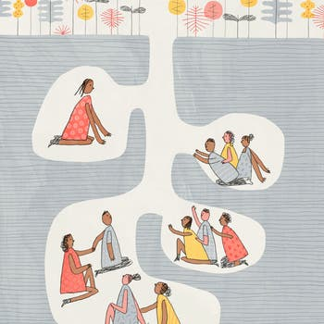](https://www.nytimes.com/2021/04/23/style/modern-love-polyamory-should-my-boyfriend-love-one-woman-or-three.html?action=click&algo=bandit-all-surfaces-engagement-time-weight&block=editors_picks_recirc&fellback=false&imp_id=159887667&impression_id=04e41570-a469-11eb-93bb-59177b846311&index=1&pgtype=Article&pool=editors-picks-ls&region=ccolumn&req_id=809346724&surface=home-featured&variant=5_bandit-all-surfaces-engagement-time-weight)](https://www.nytimes.com/2021/04/23/style/modern-love-polyamory-should-my-boyfriend-love-one-woman-or-three.html?action=click&algo=bandit-all-surfaces-engagement-time-weight&block=editors_picks_recirc&fellback=false&imp_id=159887667&impression_id=04e41570-a469-11eb-93bb-59177b846311&index=1&pgtype=Article&pool=editors-picks-ls&region=ccolumn&req_id=809346724&surface=home-featured&variant=5_bandit-all-surfaces-engagement-time-weight)

[My Boyfriend Has Two Girlfriends. Should I Be His Third?](https://www.nytimes.com/2021/04/23/style/modern-love-polyamory-should-my-boyfriend-love-one-woman-or-three.html?action=click&algo=bandit-all-surfaces-engagement-time-weight&block=editors_picks_recirc&fellback=false&imp_id=159887667&impression_id=04e41570-a469-11eb-93bb-59177b846311&index=1&pgtype=Article&pool=editors-picks-ls&region=ccolumn&req_id=809346724&surface=home-featured&variant=5_bandit-all-surfaces-engagement-time-weight)

[[](https://www.nytimes.com/2021/04/21/technology/welcome-to-the-yolo-economy.html?action=click&algo=bandit-all-surfaces-engagement-time-weight&block=editors_picks_recirc&fellback=false&imp_id=791234915&impression_id=04e41571-a469-11eb-93bb-59177b846311&index=2&pgtype=Article&pool=editors-picks-ls&region=ccolumn&req_id=809346724&surface=home-featured&variant=5_bandit-all-surfaces-engagement-time-weight)](https://www.nytimes.com/2021/04/21/technology/welcome-to-the-yolo-economy.html?action=click&algo=bandit-all-surfaces-engagement-time-weight&block=editors_picks_recirc&fellback=false&imp_id=791234915&impression_id=04e41571-a469-11eb-93bb-59177b846311&index=2&pgtype=Article&pool=editors-picks-ls&region=ccolumn&req_id=809346724&surface=home-featured&variant=5_bandit-all-surfaces-engagement-time-weight)

[Welcome to the YOLO Economy](https://www.nytimes.com/2021/04/21/technology/welcome-to-the-yolo-economy.html?action=click&algo=bandit-all-surfaces-engagement-time-weight&block=editors_picks_recirc&fellback=false&imp_id=791234915&impression_id=04e41571-a469-11eb-93bb-59177b846311&index=2&pgtype=Article&pool=editors-picks-ls&region=ccolumn&req_id=809346724&surface=home-featured&variant=5_bandit-all-surfaces-engagement-time-weight)

[Continue reading the main story](https://www.nytimes.com/2019/11/12/books/review/the-iliad-a-graphic-novel-adaptation-gareth-hinds.html#after-pp_edpick)

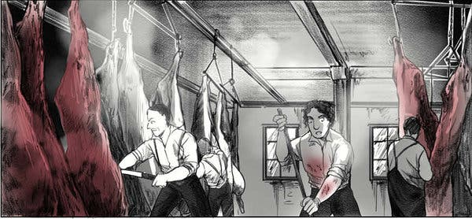

Image



Kristina Gehrmann’s judicious splashes of color lend a poignancy to her adaptation of Upton Sinclair’s “The Jungle.”Credit...From "The Jungle"

On the ugly truths front, this year also brings **ANIMAL FARM: The Graphic Novel** (Houghton Mifflin Harcourt, $22), adapted from George Orwell’s 1945 allegorical novella and illustrated by the Brazilian cartoonist Odyr. “Animal Farm” has previously appeared accompanied by drawings, by famous illustrators — Ralph Steadman, and Quentin Blake, whose charming linework one might recognize from many Roald Dahl editions. But Odyr, using a bright palette, has fully adapted what Orwell called “a fairy tale” satirizing Stalin — and the result is elegant and heartbreaking. Odyr’s images of animals casting off their bonds and then living with the results of their revolution are painterly and evocative, both loose and illuminating. Instead of a reduction of the original, Odyr’s imagined barnyard world adds to the depth of the characters: His pigs, horses, sheep and hens have expressive faces and postures, revealing both sweetness and malevolence.

An animal-driven story in a different key whose shocking graphic descriptions seem to beg for visual adaptation (some already exist), Upton Sinclair’s **THE JUNGLE**(Ten Speed, $24.99) is now out in an almost 400-page graphic novel adapted and illustrated by the German artist Kristina Gehrmann, and translated by Ivanka Hahnenberger. Cartoonists such as Peter Kuper — also one of the editors behind the long-running political comics magazine World War 3 Illustrated — have previously taken on “The Jungle”; Kuper’s newest adaptation is **JOSEPH CONRAD’S HEART OF DARKNESS**(Norton, $21.95)**.**Gehrmann is a fluid and controlled artist, and her absorbing take on the muckraking 1902 novella, which exposed the unclean, unsafe and exploitative Chicago stockyards and the lives of its immigrant labor force, differs in some substantial ways from the original. But it works well on its own terms: It’s a page-turner. Most haunting about the book are the scenes of animals — live or dead or about to be killed, ready to have their corpses split or trimmed. Some characters, like the protagonist Jurgis Rudkus, a young Lithuanian immigrant, have simplified and exaggerated features, underlining his earnest Everyman quality. But the animals — such as the small, diseased pigs Jurgis is paid to process at work after the inspectors have gone home — exist on the page with affecting precision. And while Gehrmann’s Chicago appears in a grim graytones throughout, she ingeniously colors bits and pieces a light red that throbs. Sometimes this is blood, seeping from an animal, but sometimes it’s a scarf of a beloved central character; eventually, ominously, the red spreads and becomes the sky. Unlike the red coat on a little girl in the otherwise black-and-white “Schindler’s List,” which Spielberg used to track and humanize, Gerhmann’s red, a silent visual narrative, moves freely, uncontained, appearing here and there, marking an existential malady.

Hillary Chute is the author, most recently, of “Why Comics? From Underground to Everywhere,” now out in paperback.

*Follow New York Times Books on [Facebook](https://www.facebook.com/nytbooks/),*[*Twitter*](https://twitter.com/nytimesbooks)*and [Instagram](https://www.instagram.com/nytbooks/), sign up for*[*our newsletter*](https://www.nytimes.com/newsletters/books-review)*or*[*our literary calendar*](https://www.nytimes.com/interactive/2017/books/books-calendar.html)*. And listen to us on the*[*Book Review podcast*](https://www.nytimes.com/column/book-review-podcast)*.*

A version of this article appears in print on Nov. 24, 2019, Page 26 of the Sunday Book Review. [Order Reprints](http://www.nytreprints.com/) | [Today’s Paper](https://www.nytimes.com/section/todayspaper) | [Subscribe](https://www.nytimes.com/subscriptions/Multiproduct/lp8HYKU.html?campaignId=48JQY)