**Krazy Love**

BY [R.C. HARVEY](http://www.tcj.com/author/bob-harvey/) JAN 20, 2017

We don’t have to penetrate more than a fraction of an inch into Michael Tisserand’s inch-and-a-half thick, three-pound 545-page biography of Krazy Kat’s kreator to realize that it is a stupendous triumph of exhaustive research and organizational skill. I’ve read only the first two chapters of *Krazy: George Herriman, A Life in Black and White,* and I already know more about this shy genius than I ever expected to know. But we don’t have to read even that much to realize that this volume is a biography of the cartoonist, not a critique of his work.

Just riffling the pages of the book reveals that not much of Herriman’s comic strip art is on display, and without visual evidence, we can’t examine or much appreciate his cartooning achievement. And besides, Tisserand himself tells us in an author’s introductory note that “the dimensions of this book do not allow for a full presentation of Herriman’s grand comics.” In fact, there are no complete comic strips on display This book is deliberately not about comic strip artistry. And he tells us exactly that right at the beginning: none of Herriman’s “grand comics.”

Just biography then? No, there’s a little more. “I have included panels from his works to illustrate certain ideas and to give at least a hint of their splendors.”

And so on page 24, we have a panel in which Ignatz, sending a brick to Krazy’s head, exclaims: “You’re now a member of the fraternal brickhood of noble dornicks.” This alludes to Herriman’s father’s involvement with the Masons.

Other individual panels illustrate Herriman’s sensitivity about race and identity and racial identity—Krazy looking at himself in the mirror, making black coffee (“look unda the milk”), going to a beauty parlor and coming out blonde. [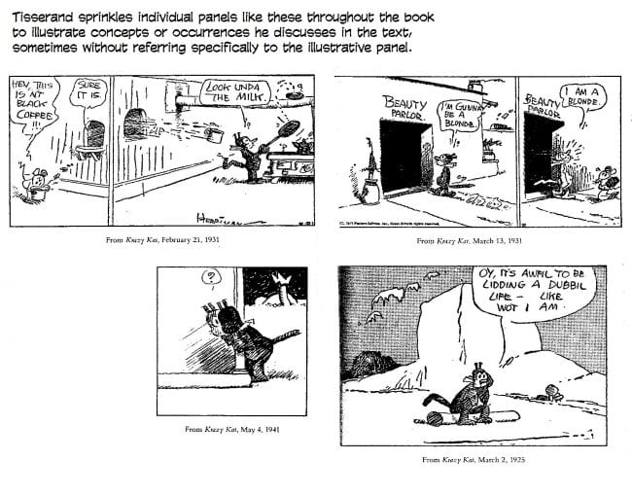](http://www.tcj.com/wp-content/uploads/2016/12/KrazyBlackCoffee.jpg)

Frustrating as it is to see so little Herriman, master of his medium and pace-setting pioneer, the book is still a monument to Tisserand’s thoroughness in research and his dexterity in weaving so much of what he found into a fascinating tapestry of Herriman’s life.

I look forward to finding more gems like this one: “Herriman began adding more decorations to his comics—especially the sun cross or wheel cross, a design common in southwestern Indian art. The symbol—a cross or X inside a circle—had special appeal to Herriman, for it also resembled the hobo symbol for a friendly household. ...”

As for Herriman's artistry, we can begin with a 1924 book, *The Seven Lively Arts*, in which art critic Gilbert Seldes famously called Herriman's comic strip about an allegedly lunatic cat "the most amusing and fantastic and satisfying work of art produced in America today."  This accolade and the accompanying lengthy analysis of the strip by one of the foremost critics of the day gave social and artistic respectability for the first time to the erstwhile "despised medium" of cartooning.  It was Seldes who first analyzed the strip's plot and articulated Herriman's theme. (And he did it without including in his discussion any examples of the comic strip; we’ll do a little better here.)

Like any great work of art, *Krazy Kat's* thematic complexity is masked by its seeming simplicity.  After a couple of formative years, the plot that emerged involved only three characters— a cat (Krazy), a mouse (Ignatz), and a dog (Offissa Pupp)— but each is doing something profoundly contrary to its nature.  Instead of stalking the mouse, Krazy loves him and waits for him to assault her; instead of fearing the Kat, Ignatz scorns her (or him— Krazy is without sex, Herriman explained, like a sprite or elf) and attacks him/her repeatedly; instead of chasing the Kat, the dog protects her/him out of love for him/her.  This is Herriman's eternal triangle; and each of its participants is ignorant of the others' passions.

Into this equation, Herriman introduced a symbol:  a brick.  Ignatz despises Krazy and expresses his cynical disdain by throwing a brick at the androgynous Kat's head.  Krazy, blind with love, awaits the arrival of the brick (indeed, pines for its advent) with joy because he/she considers the brick "a missil of affection."  Meanwhile, the dog, motivated by inclination (his love for Krazy) as well as occupation (he's an enforcer of law and order) tries to prevent the disorders that Ignatz attempts to perpetrate on Krazy's bean.

Ironically, in seeking to protect the object of his affection from the assaults of the mouse, Offissa Pupp succeeds in making his beloved Krazy happy only when he fails to frustrate Ignatz's attack.  Luckily, Offissa Pupp frequently fails in his mission.  And Ignatz, perforce, succeeds.  But it is Krazy who triumphs.  As Seldes said:  "The incurable romanticist, Krazy faints daily in full possession of his illusion, and Ignatz, stupidly hurling his brick, thinking to injure, fosters the illusion and keeps Krazy `heppy'."

Hence, Herriman's theme:  love always triumphs.  And most of the time, it does so in the strip more by accident than by design.  Over the years, Herriman played out his theme in hundreds of variations, but there was always the Kat, the Mouse, and the brick.  And the brick usually found its way to Krazy's skull— much to the Kat's content (and often to Offissa Pupp's chagrin).  The acclaimed lyricism of Herriman's strip arises partly from the seemingly endless reprise of this theme as Seldes first outlined it.  But it arises, too, from the theme itself and Herriman's unique treatment of it.

For we are all of us lovers, seeking someone to love and to love us back— and fearing an unrequited outcome.  That we should find humor in a comic strip about love that is requited more by accident than by intention is something of a wonder.  True, there is some reassurance in the endless victories of love in *Krazy Kat*.  But the accidental nature of so many of those triumphs cannot but undermine a little an over-all impulse towards confidence.  And hope.  And yet we laugh.  Perhaps because we are all of us lovers, and just a little krazy in konsequence.  And so like Herriman's sprite, we persist in seeing only what we want to see.

By this circuitous route, Seldes' interpretation of Herriman's theme is embellished.  *Krazy Kat* is not so much about the triumph of love as it is about the unquenchable will to love and to be loved.  Love may not, in fact, always triumph; but we will always wish it would. [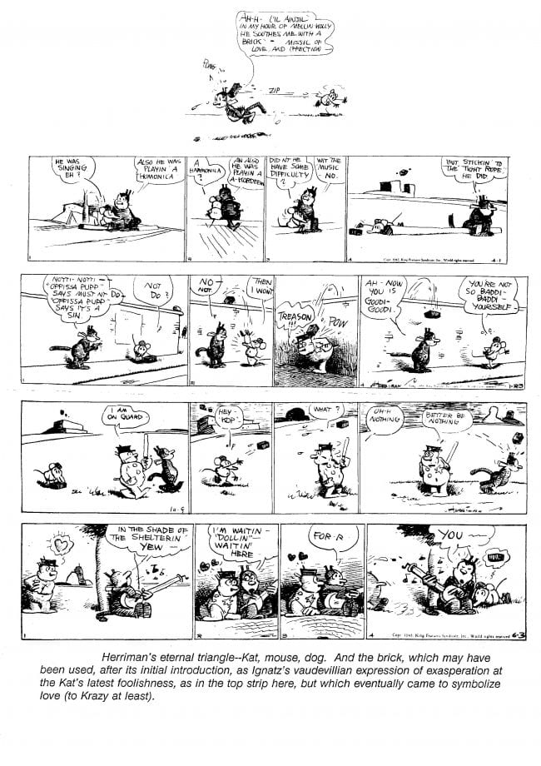](http://www.tcj.com/wp-content/uploads/2016/12/Krazy1.jpg)

Herriman's paean to love began as a simple cat-and-mouse game in the basement of a strip called *The Family Upstairs*, which first appeared August 1, 1910. The strip had debuted under the title *The Dingbat Family* on June 20, 1910, but when the apartment-dwelling Dingbats developed an obsession about the disruptive doings of their upstairs neighbors, the strip was re-titled accordingly.  Krazy first appeared (unnamed) as the Dingbat's cat in the first week of strips.  The spacious panels in which Herriman recorded the daily trials of the Dingbats in their feud with their neighbors always had some vacant space at the bottom, and Herriman developed the practice of filling that space with drawings of the antics of the cat (not yet Kat).  On July 26, a mouse appears and throws what might be a piece of brick at the cat.  Thereafter, the drama that unfolds at the feet of the Dingbats focuses on the aggressive mouse's campaign against the cat.

By mid-August, Herriman had drawn a line completely across the lower portion of his strip, separating the cat and mouse game into a miniature strip of its own, a footnote feud paralleling the combat going on above.  This tiny strip Herriman introduced with the prophetic caption:  "And this," with an arrow pointing to the strip at the right, "another romance tells."  And the mouse ends that day's antics by christening his nemesis:  "Krazy Kat," he growls, somewhat disgustedly.  This exasperated utterance would become the strip's concluding refrain and, eventually, its title.  But for the next two-and-a-half years, the Kat and the mouse carried on in their minuscule sub-strip without a title, and the mouse didn't acquire his name until the first days of 1911.  On rare occasions, Ignatz and Krazy invaded the Dingbats' premises, taking over the more commodious panels upstairs for their daily turn while the baffled Dingbats looked in from below.  [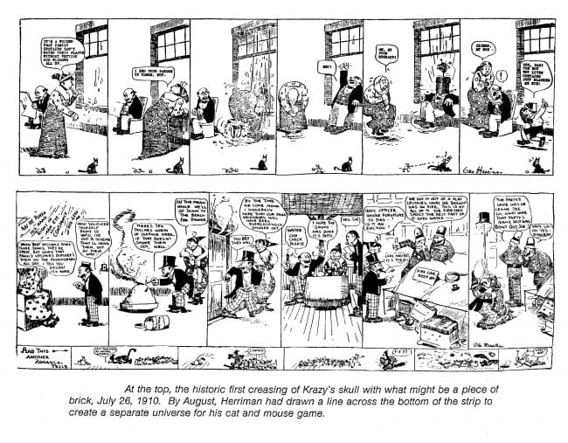](http://www.tcj.com/wp-content/uploads/2016/12/Krazy2.jpg)But it wasn't until October 28, 1913, that they had a strip of their own.

Krazy’s relationship to Ignatz was initially that of the persecuted and abused. The Kat’s infatuation with the mouse did not become evident until the spring of 1911, and even then, it was only occasionally alluded to. It did not become an obsession until later that year. In the copiously annotated Gallery at the end of this essay is a selection of strips from the first couple years, showing the evolution of the krazy love affair. [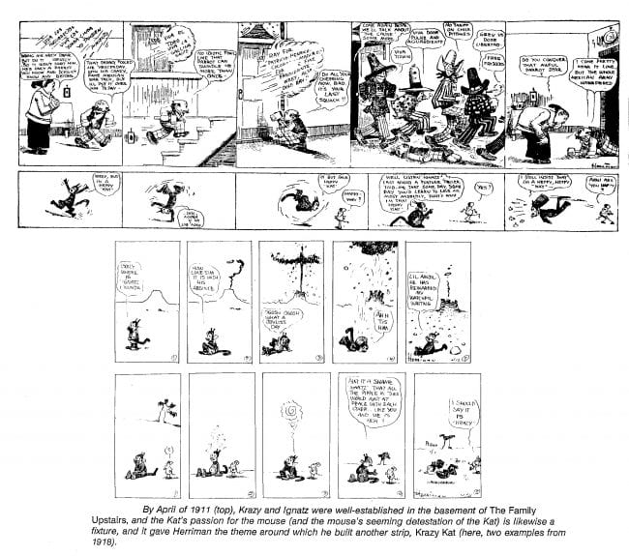](http://www.tcj.com/wp-content/uploads/2016/12/Krazy3.jpg)

The machinations of his eternal triangle (and the brick) preoccupied Herriman throughout *Krazy Kat's* run.  And most of the strips, whether daily or weekend editions, are stand-alone, gag-a-day productions.  But on occasion, Herriman told continuing stories.  Once Krazy was captivated by a visiting French poodle named Kisidee Kuku.  And in 1936, Herriman conducted one of his longest continuities— a narrative opus chronicling the havoc wreaked by Krazy's involvement with the world's most powerful katnip, "Tiger Tea."  Mostly, however, the strip was a daily dose of Herriman's lyric comedy about love.

Herriman's graphic style— homely, scratchy penwork— remained unchanged through *Krazy Kat's* run, but the cartoonist explored and exploited the format of his medium, exercising to its fullest his increasingly fanciful sense of design— particularly when drawing the Sunday *Krazy*.

The first "Sunday page" didn’t appear on a Sunday: it showed up on Saturday, April 23, 1916, running in black and white in the weekend arts and drama section of Hearst's *New York Journal*; the full-page *Krazy* would not be printed in color until June 1, 1935.  But with or without color, the full-page format stimulated Herriman's imagination, and for it, he produced his most inventive strips— in both layout and theme, the latter often playfully determined by the former, as we shall see anon.

While the brick is the pivot in most of Herriman's strips, the daily strips also reveal him playing with language and being self-conscious about the nature of his medium.  When Ignatz casually observes that "the bird is on the wing," Krazy investigates and reports (in characteristic patois):  "From rissint obserwation, I should say that the wing is on the bird."  Another time, he is astonished at bird seed— having believed all along that birds came from eggs.

In Krazy's literal interpretation of language there is an innocence at one with his romantic illusion.  When Ignatz is impressed by a falling star, Krazy allows that "them that don't fall" are more miraculous.  Krazy's puns and wordplay were the initial excuse for Ignatz's assault by brick:  the mouse stoned the Kat to punish him/her for what he considered a bad joke.  From this simple daily ritual, Herriman vaulted his strip into metaphysical realms and immortality.

Appropriately enough, illusion and reality meet in a dreamscape where the distinction between them becomes forever lost, the perfect denouement for the topsy-turvy relationship among Herriman's trio of protagonists.  Seldes drew attention to the "shifting backgrounds" in *Krazy Kat*— to scenery that changes from mountain to forest to sea at will, to suit Herriman's whim for varying his designs.  Very early, in both daily and weekend installments, Herriman invested his strip with a dream-like ambiance:  evoking his favorite retreat, Monument Valley in the desert of southeastern Utah, he created a Surreal landscape of whimsical buttes and cavorting cactuses that changed their shapes and moved around from panel to panel as his characters capered before it, entirely oblivious to the metamorphosis of their background.  In the radiant absurdity of this symbolic site, the Herriman's lyricism was complete:  setting and content were a seamless whole, locale and refrain united in thematic reprise.  Here, Herriman's dream becomes an amiable reality.

In addition to being a conglomeration of geological oddities, Monument Valley is a desert.  Its landscape is parched and vast; its human population, sparse.  Here, dwarfed by craggy monuments and isolated from the normal bustle of social enterprise, the solitude and insignificance of individual existence becomes a palpable thing.  Baking in the desert sun, soaking up the peace and majesty of the place and finding withal a kind of serenity, one can come to a great appreciation of the fellowship of humankind— perhaps to an understanding of the role of love in that fellowship.

Whether Herriman experienced precisely these feelings we cannot say, but he was clearly moved by the beauty of the area:  "Those mesas and sunsets out in that ole pais pintado," he once wrote, "a taste of that stuff sinks you ... deep too...."  For twenty years, he made an annual pilgrimage every summer to Monument Valley, where he stayed in Kayenta with John and Louisa Wetherill, who had started a Navajo trading post there in 1910.  Cartoonists James Swinnerton and Rudolph Dirks sometimes accompanied him.  And they all painted landscapes a little (Herriman less than the other two).

Herriman is the first person of color to achieve prominence in cartooning.  Although recognized for his talent by his peers and by the press and the public in a general way, his stature is largely a posthumous distinction.  During his lifetime, Herriman's work was esteemed by intellectuals, but their high opinion of *Krazy Kat* did not translate into circulation:  *Krazy Kat* appeared in very few newspapers, relatively speaking.  Ron Goulart, in his *Encyclopedia of Comics*, says the strip never ran in more than forty-eight papers in this country.  Half of them were doubtless in the Hearst chain, which numbered about two dozen at its peak.  Hearst loved the strip and insisted that he would keep running it as long as Herriman wanted to do it, circulation notwithstanding.

Herriman is reported to have said he was Creole but of mixed blood.  Thanks to Tisserand, we know now, without quibble or question (of which there was a good deal when this ancestral fact first surfaced years ago), that Herriman was one of the "colored" Creoles who lived in New Orleans at the end of the nineteenth century— descendants of "free persons of color" who had intermarried with French, Spanish, and West Indian stock.

Herriman was clearly sensitive about his racial origins.  He was passing for white, and he had kinky black hair and so almost always wore a hat— indoors and out— probably to conceal his hair. By all accounts, he was self-effacing, shy, and extremely private.

Herriman's race would be of no particular interest were it not for the unique manifestation he created for love in his strip:  Krazy chooses to take an injury (a brick to the head) as symbolic of Ignatz's love for him/her, and Krazy is a black cat.  While I would hate to see *Krazy Kat* converted by well-meaning critics and scholars into an allegory about racial relations (it would then seem somehow less universal in its message, and we all need its reassurances, regardless of race), Herriman's sensitivity on the matter suggests an unconscious emotional source for his inspiration.

He may not have been fully conscious of the kind of self-hatred that racial prejudice induces in persecuted minorities, but his subconscious knew.  And on the murkier levels of the subconscious, self-hatred is associated with guilt, and guilt requires punishment.  And thus the brick, erstwhile emblem of love, becomes the instrument of punishment.  But not altogether:  perhaps to Ralph Ellison's invisible man, even abuse is a form of acknowledgment and is therefore to be desired if all other forms fail to materialize.

African American scholars see other artifacts of life in black America in the strip.  William W. Cook, a Dartmouth scholar of African-Americana, told me about the comedy of reversal that *Krazy Kat* seems to embody.  Among the characters that populated the vaudeville stage in the early years of the twentieth century were comic racial stereotypes left over from the days of minstrelsy.  A large imposing black woman and her diminutive no-good lazy husband comprised a traditional stage pair.  The comedy arose from the woman's endless beratings of her husband and his ingenuity in evading the obligations she urged upon him.  Noting Krazy's color and size relative to Ignatz, Cook sees the large black woman of the vaudeville stage in the Kat; and in the mouse, the wizened husband.  In Herriman's vision, however, their vaudeville roles have been reversed:  with every brick that reaches Krazy's skull, the browbeaten "husband" avenges himself for the years of abuse he suffered on stage.  And Offissa Pupp is another vestige of the same vaudeville act:  driven to distraction by her husband's derelictions, the scolding stage wife often concluded her rantings with the threat:  "I'm gonna get the law on you."

But the strip's central ritual has a more obvious origin in another more familiar vaudeville routine.  We see it first in Bud Fisher's *Mutt and Jeff*.  The pie-in-the-face punchline. Mutt habitually hits Jeff after Jeff makes a particular stupid remark, an echo of comedy on the vaudeville stage. Ignatz's brick-throwing belongs in the same tradition.  Krazy would say or do something silly or idiotically insightful, and Ignatz would react by braining him with a brick.  It was a commonplace of comedy in those years (and to some extent, it still is).  But Herriman, as we've seen, gave the slapstick routine a metaphysical significance it never had on stage.  And the lyric lesson came about, I believe, through the cartoonist's impulse for visual comedy.

The Sunday or weekend full-page *Krazy Kat* is the fly wheel of the strip's lyric dynamic.  And it was on these pages that Herriman developed and embroidered the strip's over-arching theme.  By the time the weekend strip was launched, *Krazy* was five years old.  In its daily version, the strip reprised its familiar vaudeville routine with an almost endless variety of nuance.  The love that this routine obscurely symbolized was only hinted at in the daily strips.  But when Herriman gained the expanded vistas of a full page upon which to work his magic, his grand but simple theme began to emerge in full flower.  And before too long, the weekend strip was a page-long paean to love—to its power, to our passionate and unwavering desire for its power to triumph over all.

I suspect that the gentle theme of love emerged on the weekend pages almost accidentally.  Judging from the earliest pages themselves, Herriman's driving preoccupation was a playful desire to fill the space by humorously re-designing it— and while he was about it, he re-designed the form and function of comic strip art as well.  Beginning with the first weekend page in 1916, we can watch Herriman as he started to experiment with the form of the medium.  Antic layouts were not long in surfacing.

On the very first weekend page, April 23, 1916, he used irregular-shaped panels, and by June, some panels were page-wide.  In July, he sometimes dropped panel borders and sometimes used circular panels instead of rectangles; by August, he was mixing all these devices.  And by the end of October, his graphic imagination was shaping the gags:  layout sometimes determined punchline or vice-versa as page design became functional as well as fanciful.

On the page for July 9, 1916, page-wide panels emphasize the vastness of the desert setting. [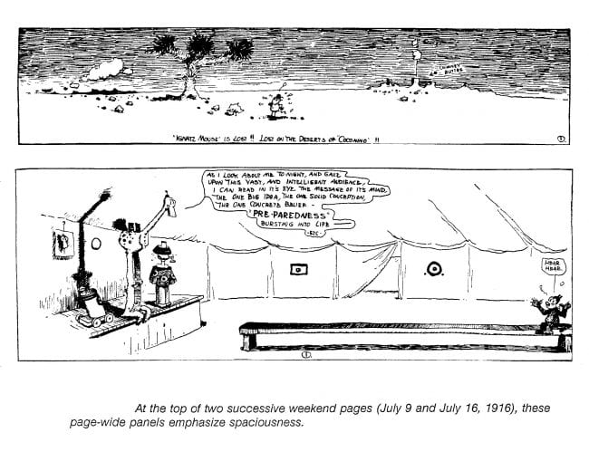](http://www.tcj.com/wp-content/uploads/2016/12/Krazy4.jpg)The opening panel the next week is likewise a whole page wide by way of dramatizing a gag:  a fatuous ostrich performer on stage addresses his "vast and intelligent audience," which consists solely of Krazy, whose solitude and inconsequence, in comic contrast to the ostrich's remarks, is made hilariously plain by the emptiness around him that stretches all across the page.

On September 3, Herriman sets the scene for an adventure at sea with a page-wide panel suggesting the vast and vacant reaches of an ocean.  Panel borders disappear for much of the page in order to give emphasis to the unruly waves that toss Krazy and Ignatz about.  Then, for the conclusion, panel borders frame a scene when the sea has grown calm. [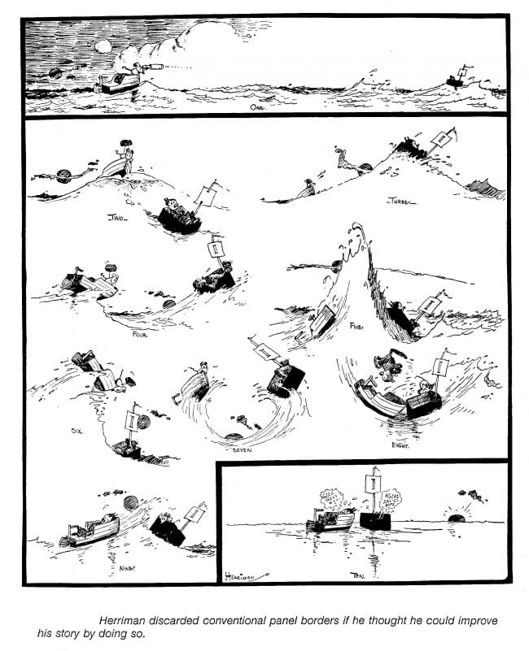](http://www.tcj.com/wp-content/uploads/2016/12/Krazy5.jpg)[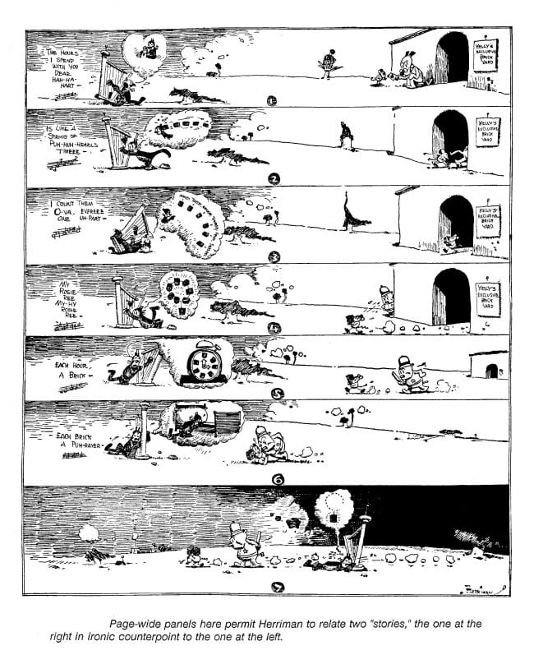](http://www.tcj.com/wp-content/uploads/2016/12/Krazy6.jpg) On October 15, the entire page consists of page-wide panels. The maneuver permits Herriman to tell one story about Krazy at the far left of each panel while unfolding an ironic comedy in counterpoint at the far right.  The humor arises from the simultaneity of the actions.

On May 6, 1917, a top-to-bottom vertical panel on the right-hand side of the page gives the comic explanation for the "mystery" outlined in the panels on the left:  how could a single brick from Ignatz bean a katbird, Krazy, and a katfish?  The vertical panel allows Herriman to explain. [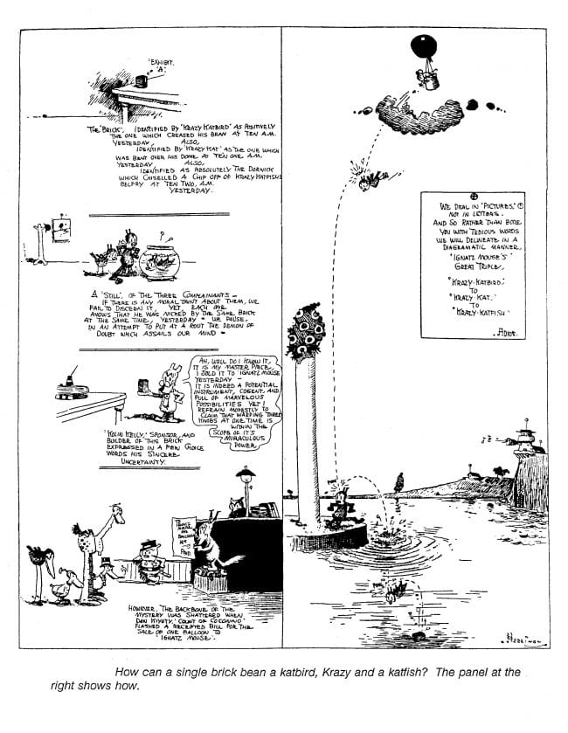](http://www.tcj.com/wp-content/uploads/2016/12/Krazy7.jpg)He shows Ignatz in a balloon over Krazy's head and traces the path of the brick he drops from the balloon:  it hits a passing katbird first, then Krazy, then falls into the water where it hits the katfish.

The next week, layout also contributes to the comedy.  The bottom third of the page is a series of drawings large enough to show Krazy bemoaning his banishment from Ignatz at the bottom of the drawings while, simultaneously at the top of each drawing, the usual missive of the mouse's regard is being launched in the Kat's direction by forces over which neither Kat nor mouse has any control. [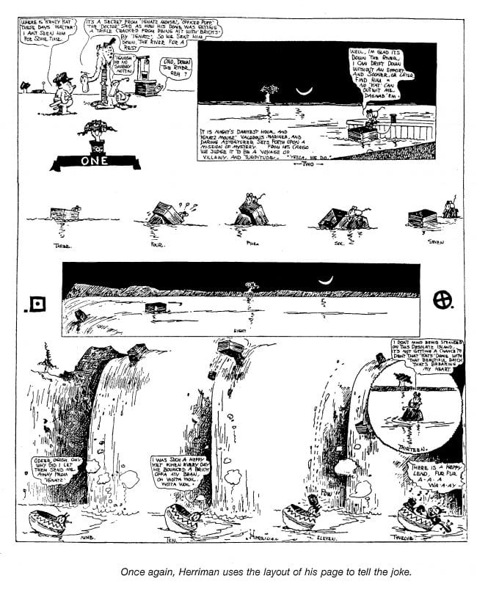](http://www.tcj.com/wp-content/uploads/2016/12/Krazy8.jpg)

That the stories Herriman told on the weekend*Krazy Kat* focussed on love is largely incidental.  Love is any storyteller's stock-in-trade.  Love insinuates itself into most human dramas.  In many ways, all stories can be love stories—as soon as the opposite sex appears or children enter a family milieu.  Love stories find their way into virtually every other kind of tale.  They fit readily into any narrative setting.  War stories have love stories as subplots; so do Westerns and whodunits and every other kind of narrative.  The theme of love is thus universal enough to furnish a focus for any story.   Herriman's sense of graphic play needed a narrative focal point.  Love was the most easily understood and adaptable organizing device at hand.  Herriman seized it, and, by making it central to an endless comic refrain, he made poetry.

On the weekend pages, Herriman found room to indulge and develop his fantasy— his visual playfulness, his inventiveness.  His poetry.  Here, then, the quintessential *Krazy* blossomed.  And then the daily strips took up the chorus too, more focussed than they had been before Herriman had the weekend page to play with.  The lyricism of the theme soon permeated Herriman's week and gave us one of the masterworks of the medium.

But these are the meanderings of the critical faculty.  For the readers (and lovers) we all are, it is probably enough to know that regardless of the source of Herriman's inspiration, his Kat, the embodiment of love willed into being, is a comfort to us all— a balm of wisdom wrapped in laughter.  Herriman was not only shy:  he was, according to those who knew him, also saintly.  And so was his strip.[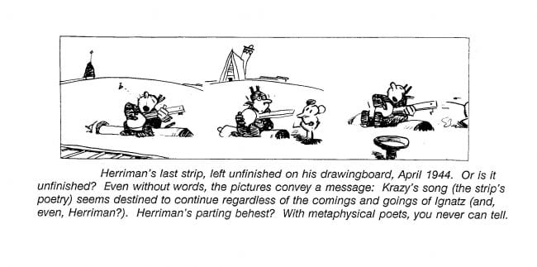](http://www.tcj.com/wp-content/uploads/2016/12/Krazy9.jpg)

Herriman died April 25, 1944, and his strip, too idiosyncratic for another to continue, ceased with the Sunday page for June 25.  But in soaring into metaphysical realms, *Krazy Kat* had long since achieved immortality.

And now, in our annotated Krazy Gallery assembled from the Hyperion Press reprint tome, *The Family Upstairs: Introducing Krazy Kat,*we show the evolution of Herriman’s most celebrated characters with sundry hints of their situation during the first months of the strip, 1910-1912. These excerpts appear here in the same order in which they were initially published, and they show Herriman becoming increasingly playful in the deployment of his medium’s visual resources—a broad hint about things to come in the “weekend” Krazy of later years.

[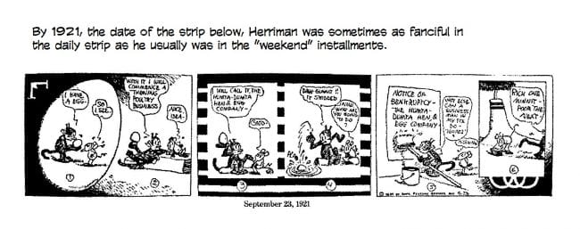](http://www.tcj.com/wp-content/uploads/2016/12/Krazy21.jpg)[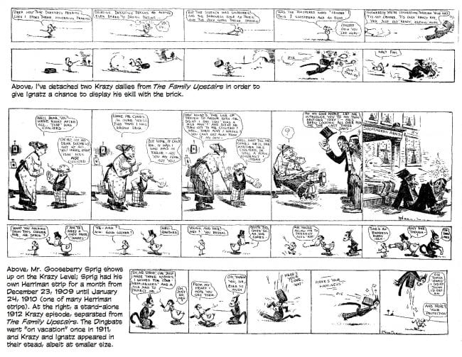](http://www.tcj.com/wp-content/uploads/2016/12/Krazy20.jpg)[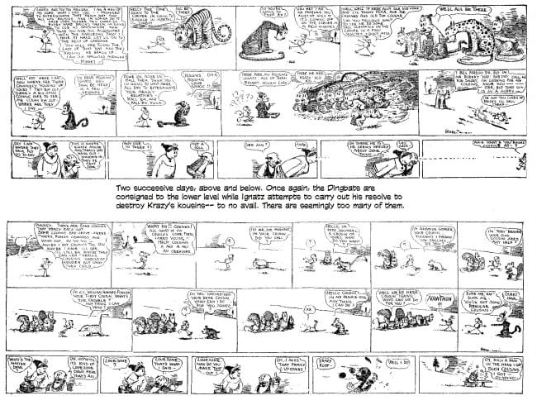](http://www.tcj.com/wp-content/uploads/2016/12/Krazy19.jpg)[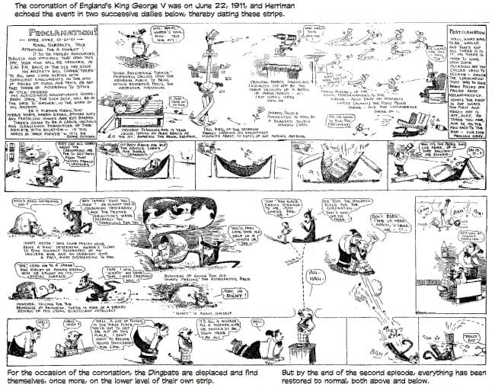](http://www.tcj.com/wp-content/uploads/2016/12/Krazy18.jpg)[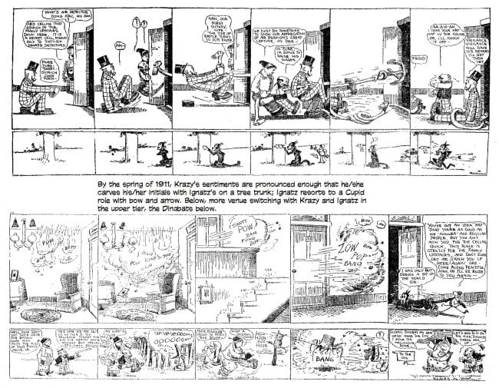](http://www.tcj.com/wp-content/uploads/2016/12/Krazy17.jpg)[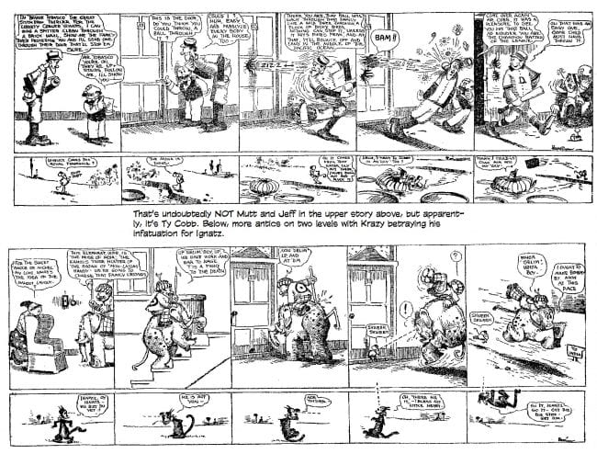](http://www.tcj.com/wp-content/uploads/2016/12/Krazy16.jpg)[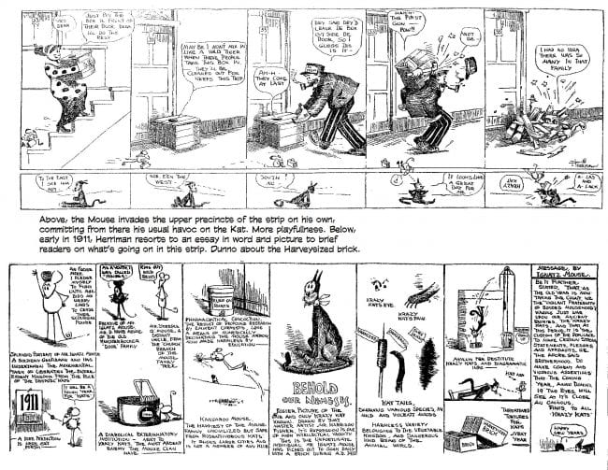](http://www.tcj.com/wp-content/uploads/2016/12/Krazy15.jpg)[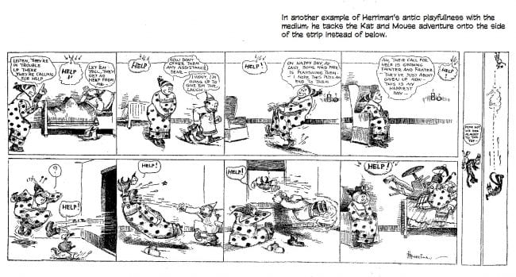](http://www.tcj.com/wp-content/uploads/2016/12/Krazy14.jpg)[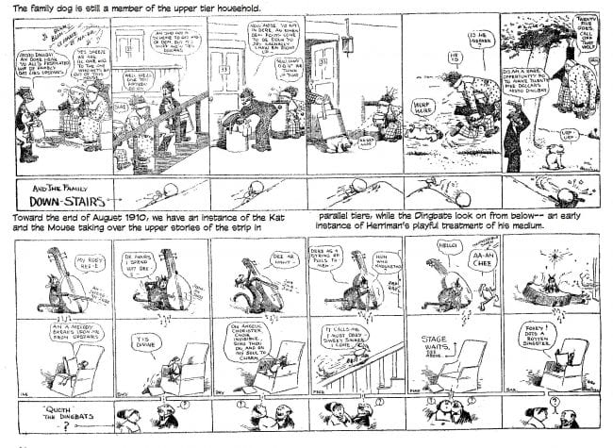](http://www.tcj.com/wp-content/uploads/2016/12/Krazy13.jpg)[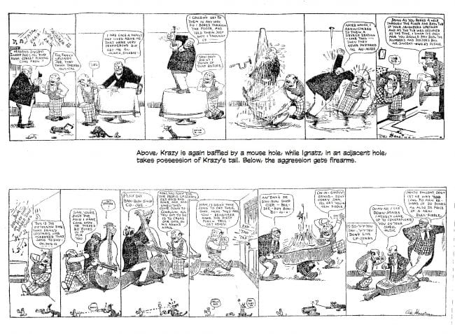](http://www.tcj.com/wp-content/uploads/2016/12/Krazy12.jpg)[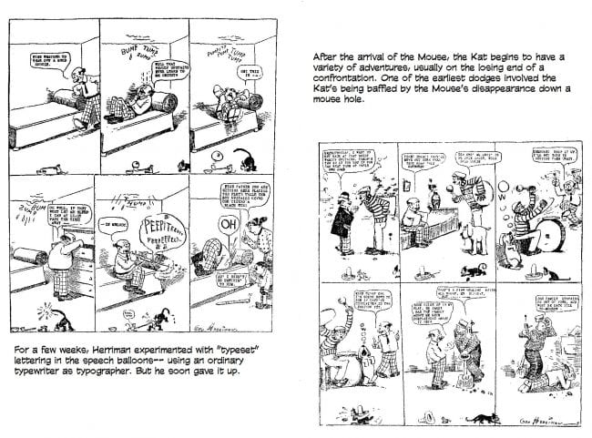](http://www.tcj.com/wp-content/uploads/2016/12/Krazy11.jpg)[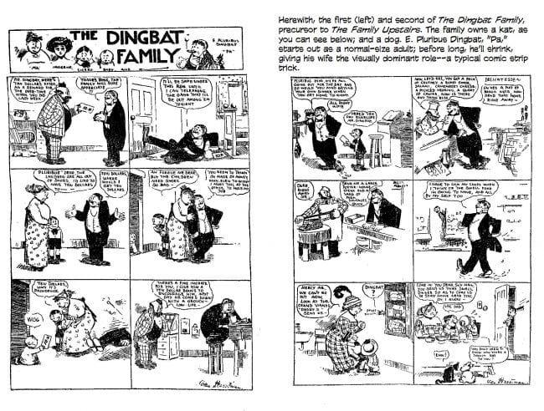](http://www.tcj.com/wp-content/uploads/2016/12/Krazy10.jpg)

[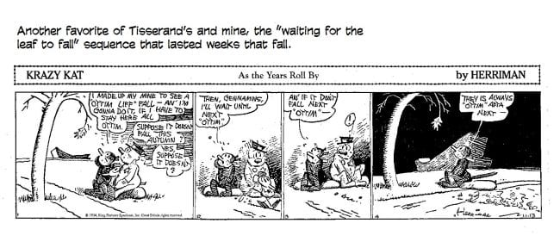](http://www.tcj.com/wp-content/uploads/2016/12/KrazyDailies4.jpg)[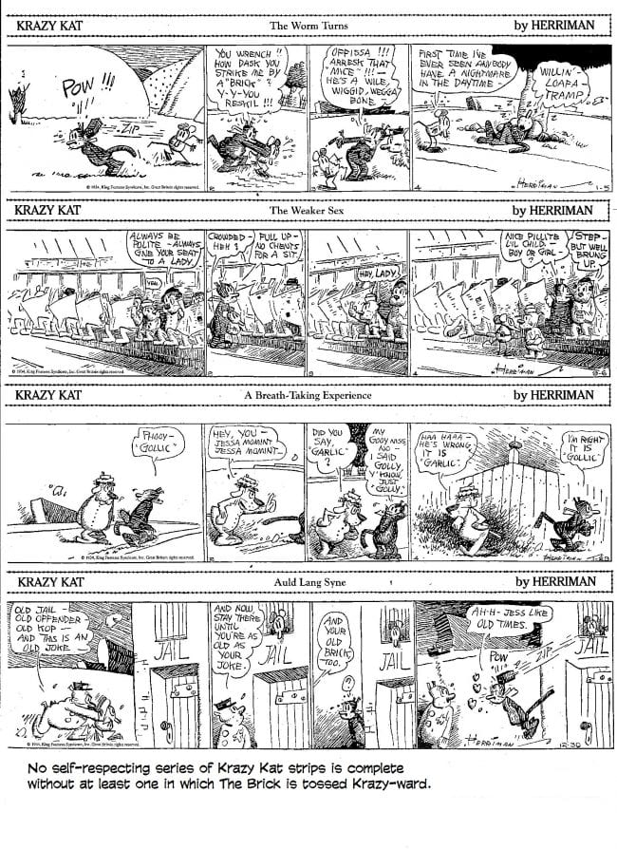](http://www.tcj.com/wp-content/uploads/2016/12/KrazyDailies3.jpg)[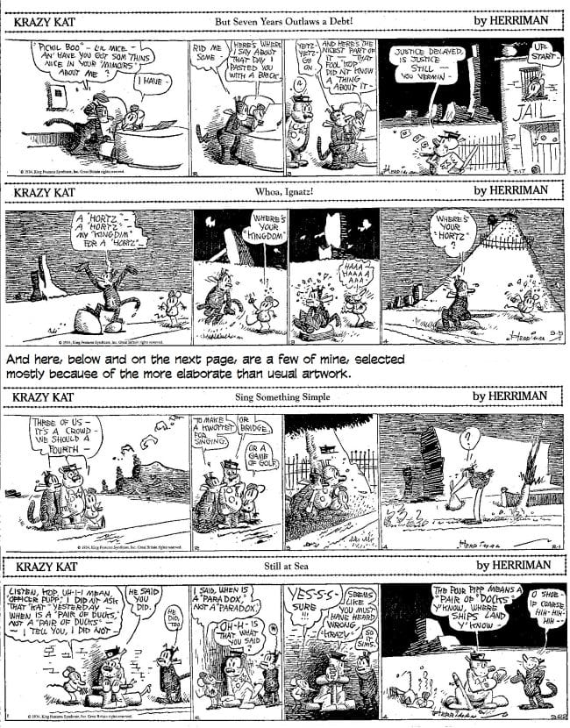](http://www.tcj.com/wp-content/uploads/2016/12/KrazyDailies2.jpg)[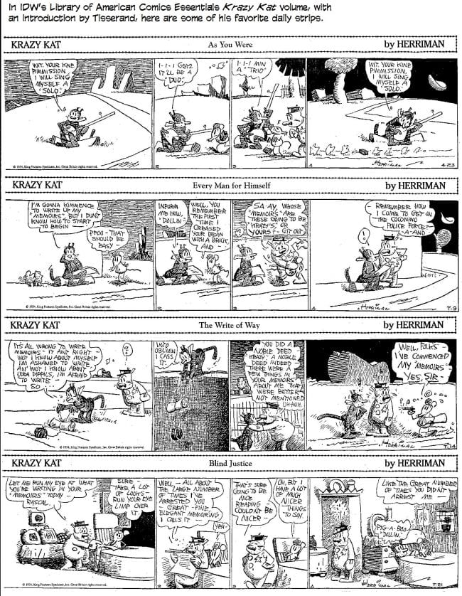](http://www.tcj.com/wp-content/uploads/2016/12/KrazyDailies1.jpg)